Project Report on

**FOOD ORDERING APPLICATION**

**Submitted By**

Shreeyash Patil CEB343

Aditya Khopade CEB326

Zaid Khalfe CEB325

Nitesh Pandey CEB340

**Guided By**

PROF. ALAMURI VASAVI



**DEPARTMENT OF COMPUTER ENGINEERING**

**Mahatma Education Society’s**

**Pillai College of Engineering**

**New Panvel**

**2022 – 2023**



Mahatma Education Society’s

Pillai College of Engineering, New Panvel – 410206

CERTIFICATE OF APPROVAL

This is to certify that the requirements for the python mini project report entitled “**FOOD ORDERING APPLICATION”** has been successfully completed by the following students:

**NAME ROLL. NO**

Shreeyash Patil CEB343

Aditya Khopade CEB326

Zaid Khalfe CEB325

Nitesh Pandey CEB340

in fulfilment of the Second year of Engineering in the Department of Computer Engineering, Pillai College of Engineering, New Panvel – 410206 during the Academic Year 2022 – 2023.

|  |  |
| --- | --- |
| **Python Programming Coordinator** | **Head of Department** |
| **PROF. ALAMURI VASAVI** | **DR. SHARVARI GOVILKAR** |

**Acknowledgement**

We would like to express our specials thanks and gratitude to Principal DR. SANDEEP JOSHI, Head of Department DR. SHARVARI GOVILKAR and Subject Coordinator PROF. ALAMURI VASAVI who gave us the opportunity to do this project **FOOD ORDERING APPLICATION**, which helped us in applying the knowledge that we have acquired during the semester and learn new concepts.

We are immensely grateful to all of them for sharing their pearls of wisdom with us during this course.

**TABLE OF CONTENTS**

## Chapter 1

## Introduction

1.1 Introduction

## Chapter 2

## Objective

2.1 Problem Definition

2.2 System Requirements

## Chapter 3

3.1 Flow of model

3.2 Technologies Used

## Chapter 4

## Implementation

4.1 System Overview

4.2 Project working with Snapshots

## Chapter 5

## Conclusion

5.1 Project Outcomes

5.2 Future Scope

5.3 References

**Chapter 1**

**Introduction**

# 1.1 Introduction

The title of the project is ‘FOOD ORDERING APPLICATION’. It is a website which is aimed at facilitating the user with delivery of meals from local restaurant and helping the local restaurant in order and inventory management. This system is a website that can be accessed by the user using URL and get the meals delivered.

Our system has an accessing mode for administer. Food ordering website is managed by an administrator. It is the job of the administrator to decide the menu and monitor the transaction process.

Administrator can perform the following operations Add the menu data, update the menu data, delete the menu data and add users to the Admin page. They can also view the order receipt data and the payment status.

**Chapter 2**

**Objective**

# 2.1 Problem Definition

With an effective ordering software, a restaurant can sell food directly to customers without the involvement of an external portal. Under this approach, the customer orders directly from your website. They browse the menu and select the menu items that they would like to order. The customer then pays for the choice and the food is delivered to their desired location or they can choose to pick it up themselves. Customers will appreciate it because it allows them to place orders quickly and easily anytime they want. They can also rest assured that when they place their orders, there will be no misunderstandings.

Many restaurants are storing all their data in a manual way. They have huge number of customers daily. So, because of large number of customers, they need help of some features so they can maintain and store their records accurately. For managers it is difficult to maintain online order list and history and the counter simultaneously. Our Food Ordering Application will provide the restaurant with efficient management of online orders and serve the purpose of the consumer. An online food ordering solution for restaurants can do wonders for you.

# 2.2 System Requirements: -

Here are the minimum and software requirements:

**Software Requirements:**

* **OS:** Windows 11, Windows 10, Windows 8 or macOS
* **Software:** Sublime Text Editor and VS Code
* **Browser:** Mozilla Firefox, Google Chrome, Apple Safari or any supported browser.

**Hardware Requirements:**

* **Ram:**  2 GB minimum, 4 GB recommended
* **Processor:**  Intel Pentium 4 or Higher

**Chapter 3**

**Methodology**

# 3.1 Flow of program

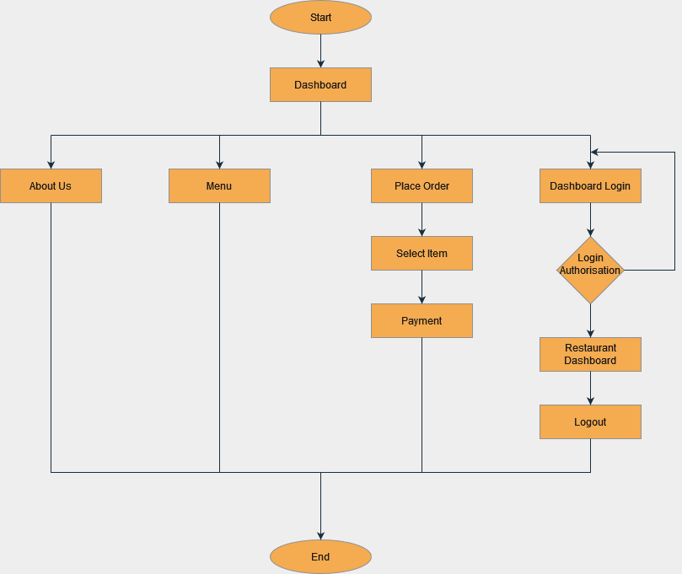

# 3.2 Technologies Used

**Django:**

Django is a Python framework that makes it easier to create web sites using Python. Django takes care of the difficult stuff so that you can concentrate on building your web applications. Django emphasizes reusability of components, also referred to as DRY (Don't Repeat Yourself), and comes with ready-to-use features like login system, database connection and CRUD operations (Create Read Update Delete).

Django follows the MVT design pattern (Model View Template).

* Model - The data you want to present, usually data from a database.
* View - A request handler that returns the relevant template and content - based on the request from the user.
* Template - A text file (like an HTML file) containing the layout of the web page, with logic on how to display the data.

## HTML:

HTML stands for HyperText Markup Language. It is used to design web pages using a markup language. HTML is the combination of Hypertext and Markup language. Hypertext defines the link between the web pages. A markup language is used to define the text document within tag which defines the structure of web pages.

**Bootstrap:**

Bootstrap is a free, open-source front-end development framework for the creation of websites and web apps. Designed to enable responsive development of mobile-first websites, Bootstrap provides a collection of syntax for template designs. As a framework, Bootstrap includes the basics for responsive web development, so developers only need to insert the code into a pre-defined grid system. The Bootstrap framework is built on Hypertext Markup Language (HTML), Cascading Style Sheets (CSS) and JavaScript.

**CSS:**

Cascading Style Sheets, fondly referred to as CSS, is a simply designed language intended to

simplify the process of making web pages presentable. CSS allows you to apply styles to

webpages. More importantly, CSS enables you to do this independent of the HTML that

makes up each web page.

## JavaScript:

JavaScript is a lightweight, cross-platform, and interpreted scripting language. It is well known for the development of web pages, many non-browser environments also use it. JavaScript can be used for Client-side developments as well as Server-side developments.

**Chapter 4**

**Implementation**

# 4.1 System Overview

Food Ordering system is a web-based system that is serving Customers and Restaurant (Admin), the main idea of our system is to allow customers to select items from the restaurant menu, enter address details and place their order. The system also allows the Restaurant to update their inventory and staff related details. Restaurant can maintain its online order list and history.

* On the main page the user will get to open the restaurant menu and a button to place an order.
* After the user clicks on Place an Order, he/she will be able to select the food items of their choice and will have to enter their details at the end of the page. To proceed with the order, Submit Order needs to be clicked which will direct them to the order summary page.
* The order summary page will have an option for payment using Paypal. Once the users click on the payment option and completes the transaction, they will be directed to the Order Submitted page.
* Admin or Restaurant manager can manage the restaurant inventory and staff login from the Django admin page.
* He can add, delete, view payment details and also can make any changes in the existing records of orders.
* To access the restaurant management page, the admin can login through the login option on the main page. Admin can see the orders, total orders, and total revenue of the day.
* Admin can check the order details of each order from the list and can mark the orders as shipped if the order is received by the costumer.

# 4.2 Project working with Snapshots

# 

**About Us Page:**

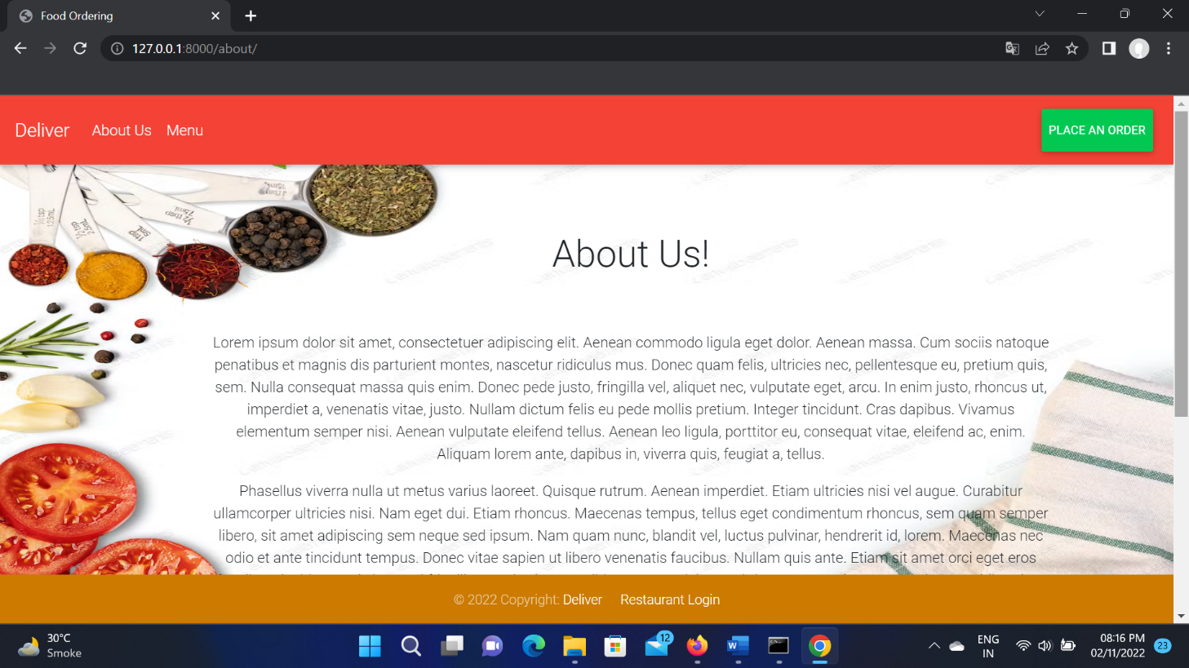

**Menu Page:**

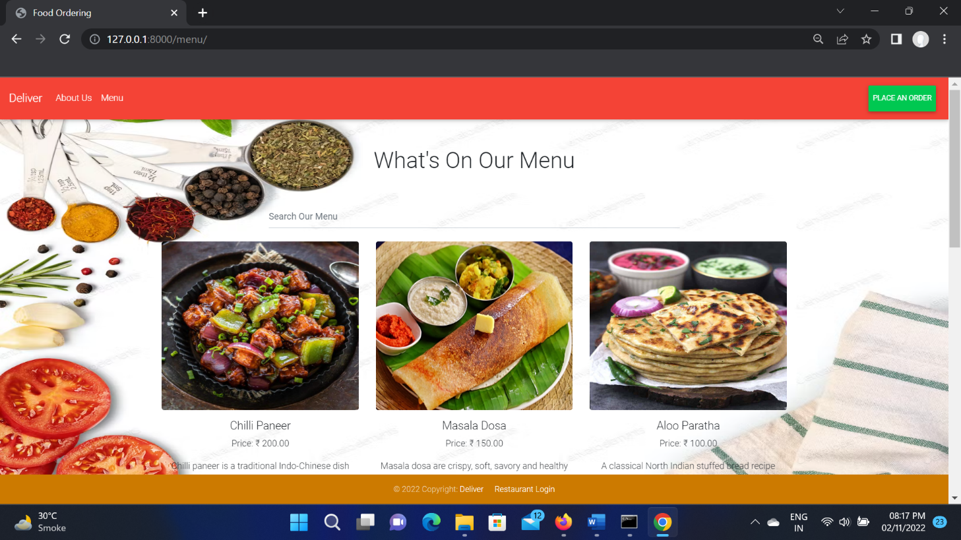

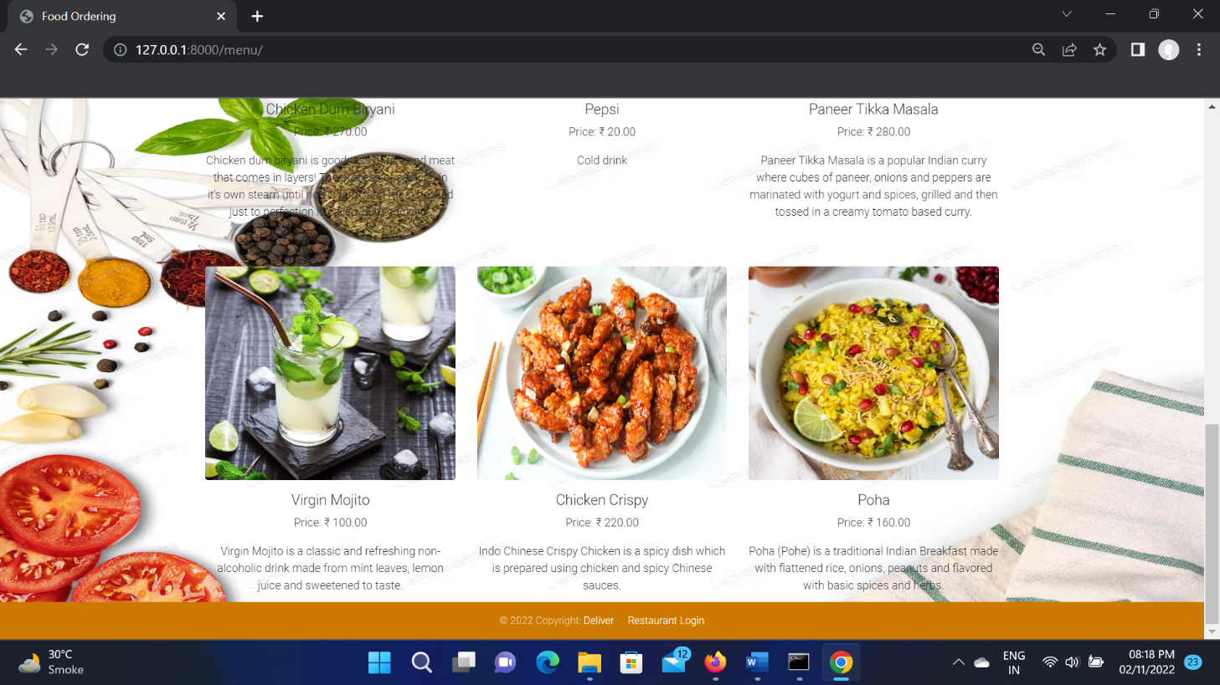

**Place An Order Page:**

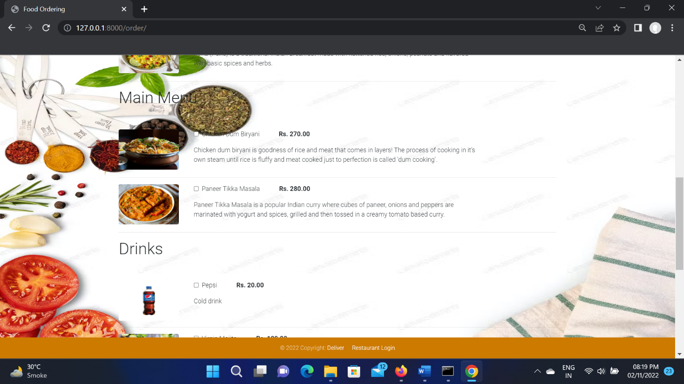

**Enter Your Details:**

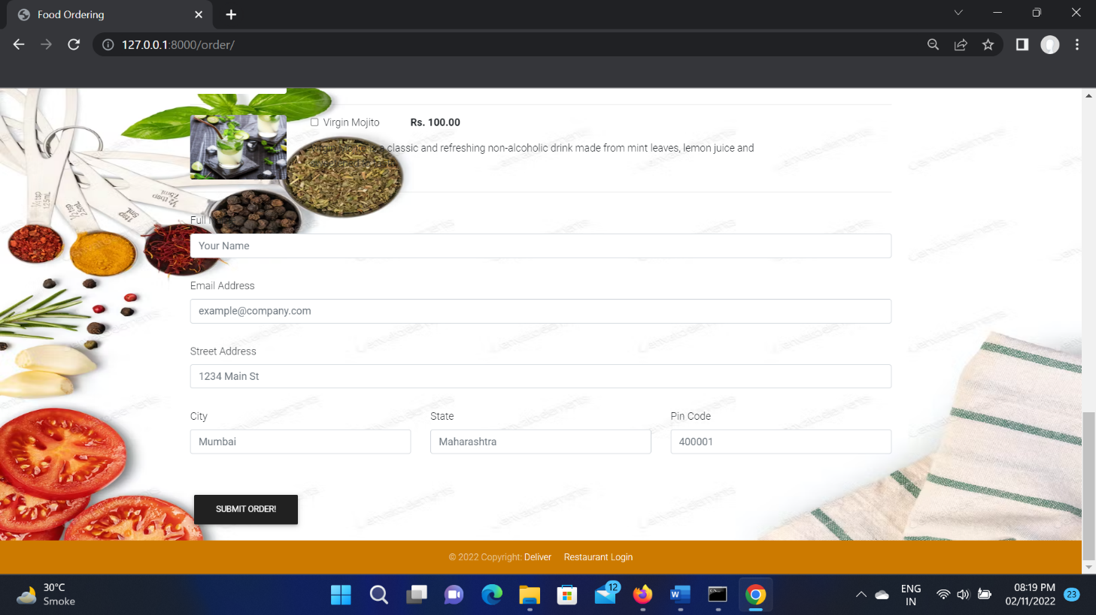

**Order Summary Page:**

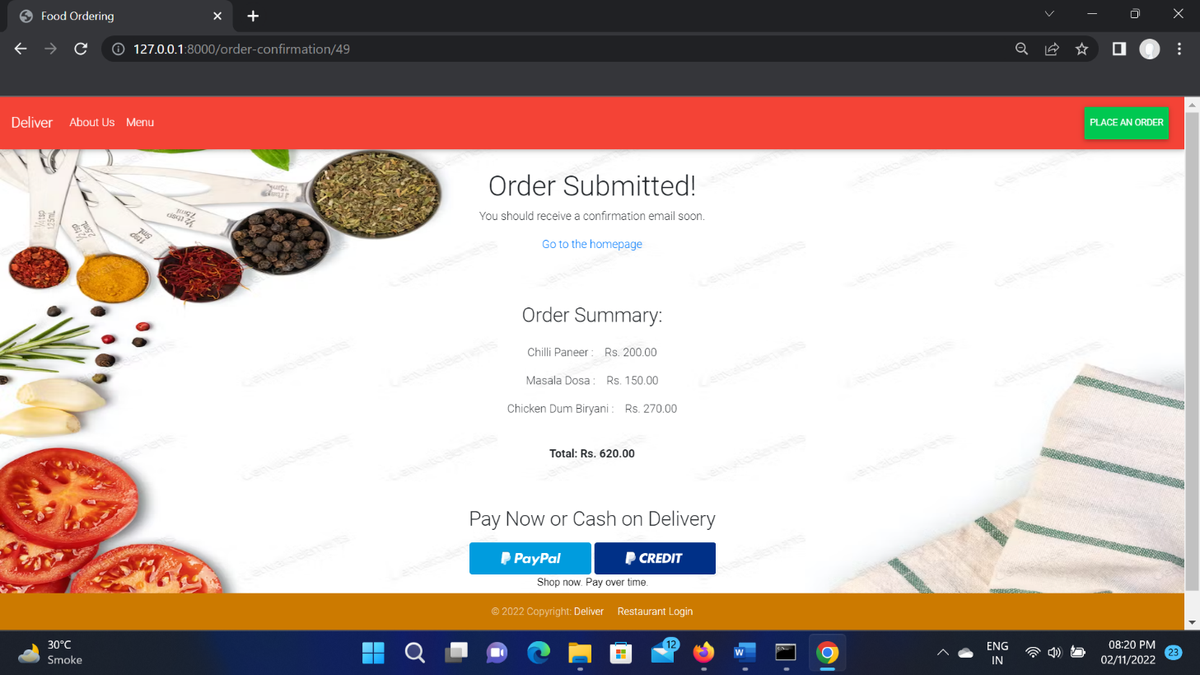

**Payment:**

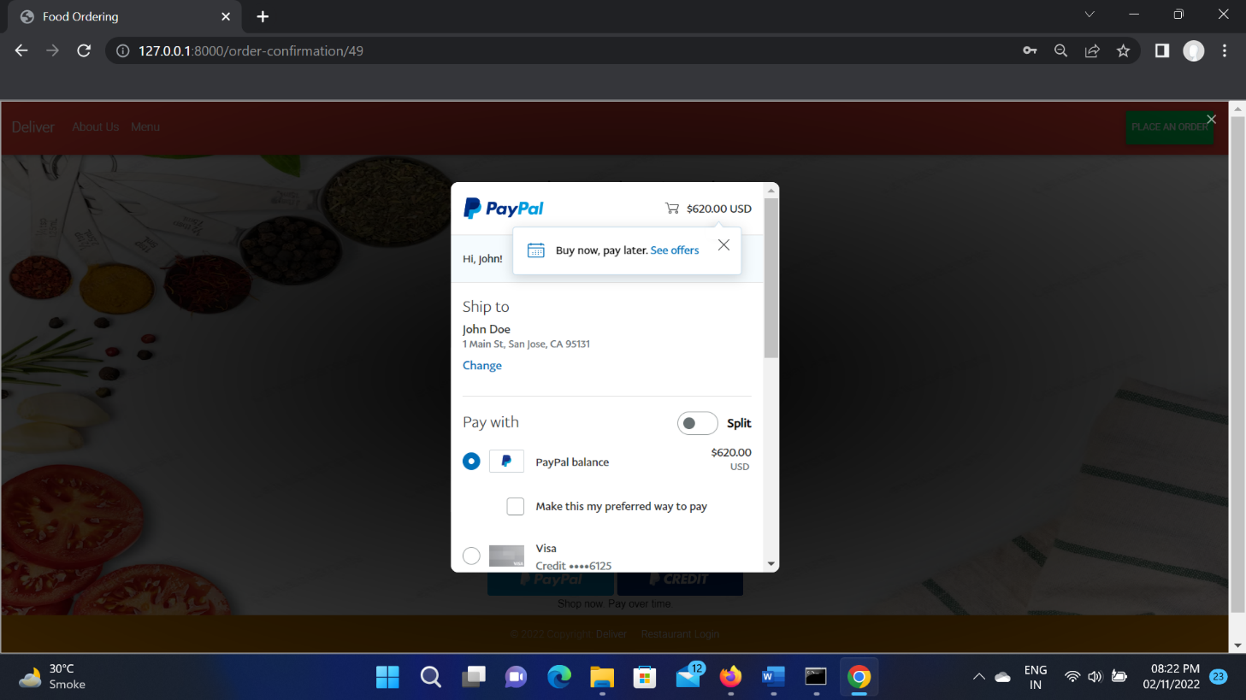

**Order Submitted Page:**

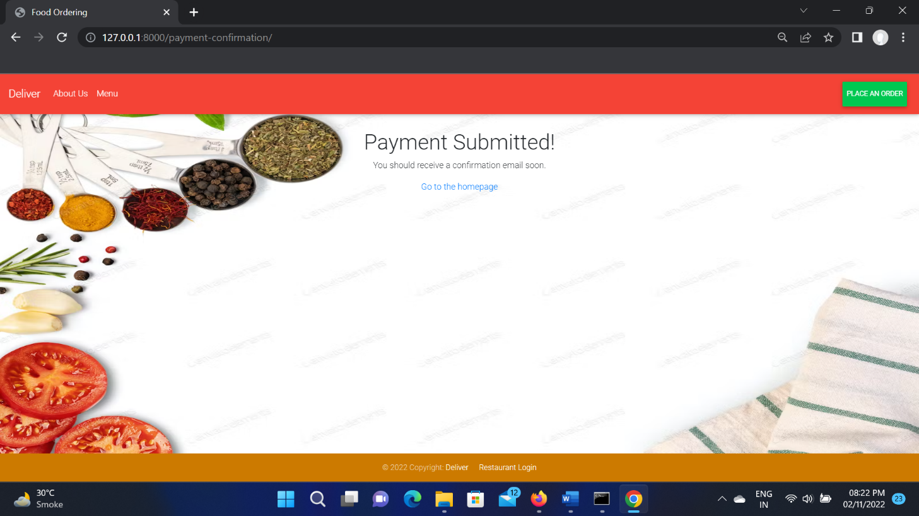

**Restaurant Dashboard Login:**

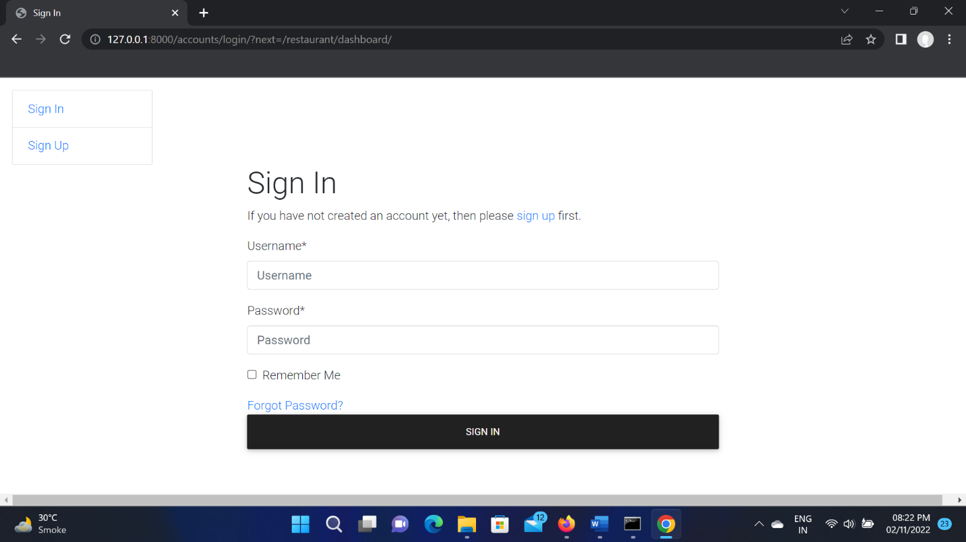

**Dashboard:**

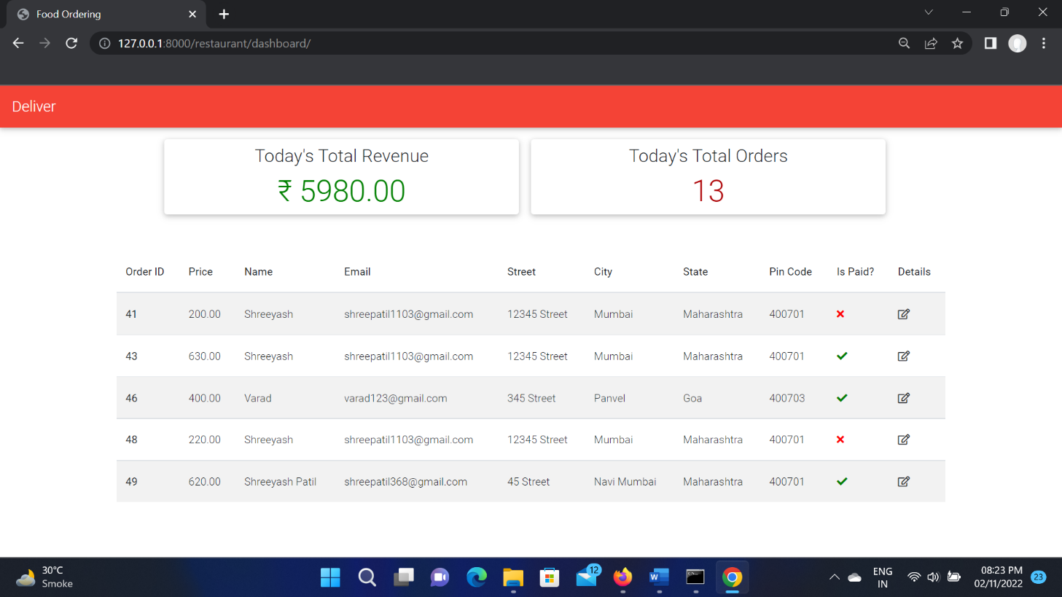

**Order Details:**

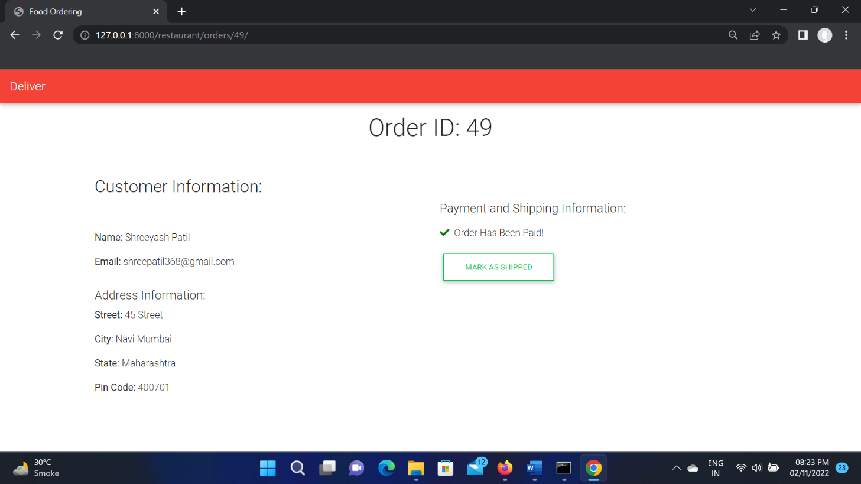

**Django Admin Profile:**

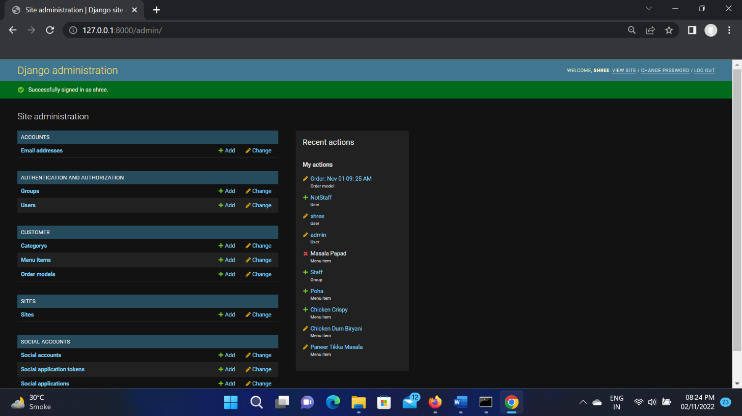

**Add and manage admin users:**

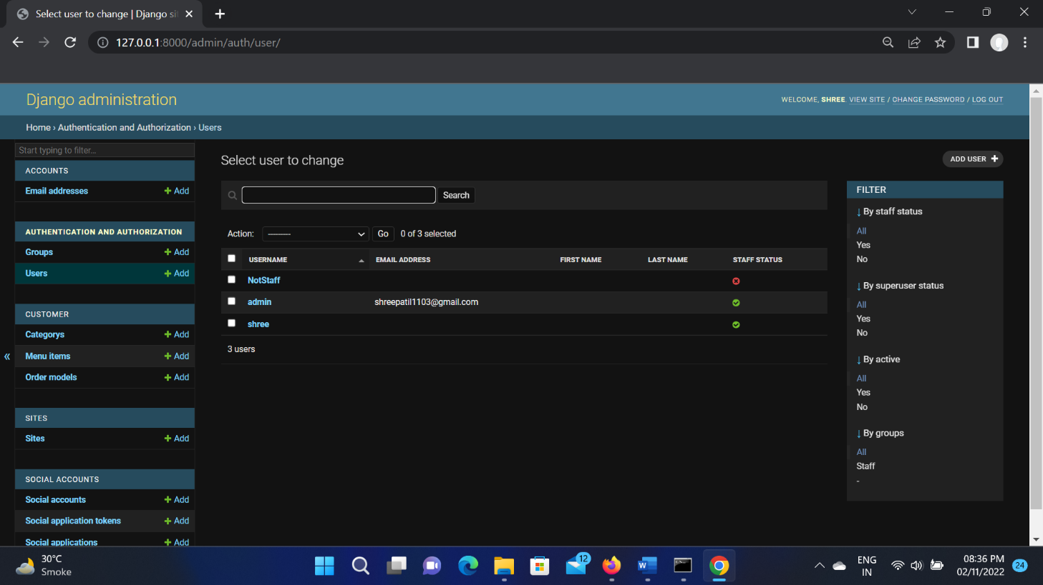

**Add and Manage menu items:**

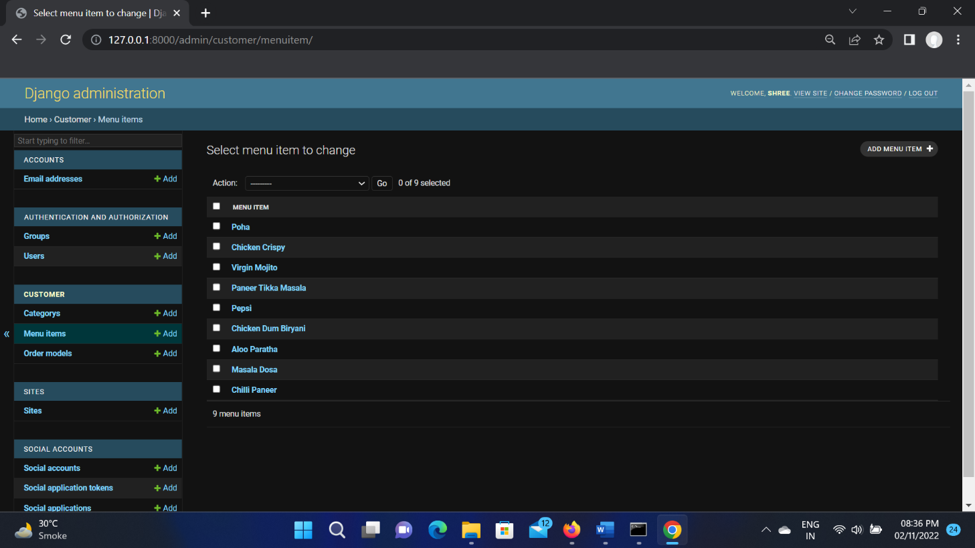

**View Order list and History:**

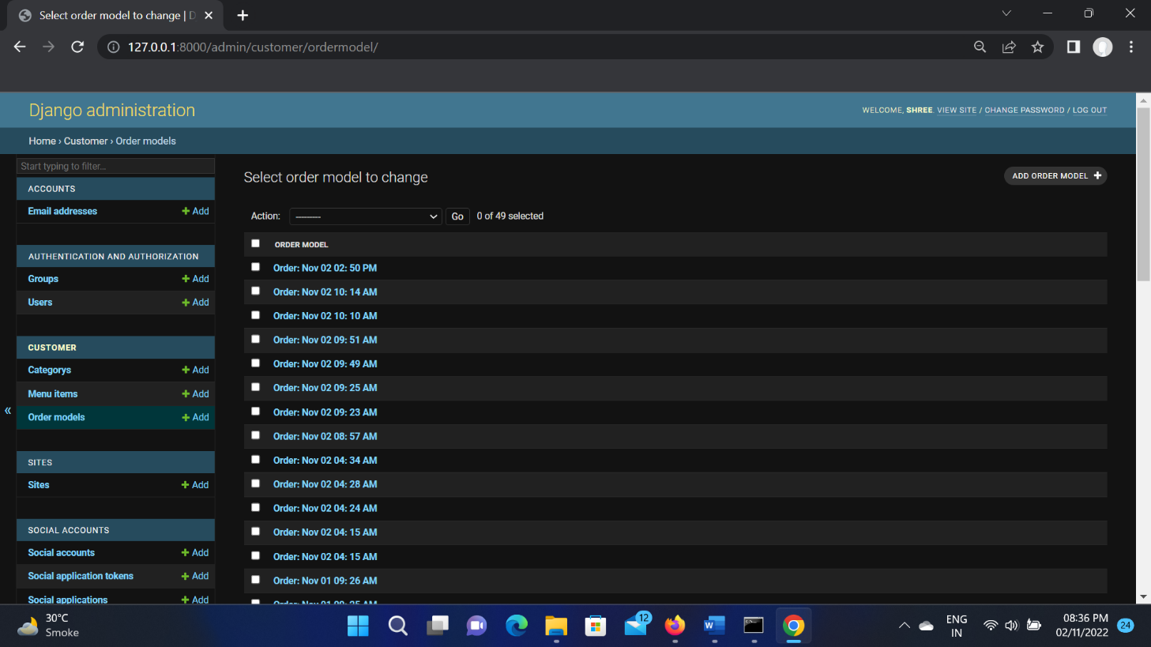

**Chapter 5**

**Conclusion**

# 5.1 Project Outcome

* In this Project we made a web page for Food Ordering Application with the help of Python-Django, HTML, Bootstrap, SQLite and made a user-friendly web site and learned about wed programming using Python.
* The Food Ordering Application makes ordering food at home easy and lightens the manual work for the Restaurant(administrator).
* It also reduces time, data loss and makes Restaurant business efficient.

# 5.2 Future Scope

This order food online system project aimed at developing an online food ordering system that can be used in small places, and medium cities firstly and then on a large scale. It is developed to help restaurants to simplify their daily operational and managerial task as well as improve the dining experience of customers.

Also, it helps restaurants develop healthy customer relationships by providing good services. The system enables staff to let update and make changes to their food and beverage list information based on the orders placed and the orders completed.

# 5.3 References

https://www.djangoproject.com/

https://getbootstrap.com/

https://bootstrapmade.com/

https://developer.paypal.com/

<https://www.w3schools.com/><https://stackoverflow.com/>

https://www.javatpoint.com/